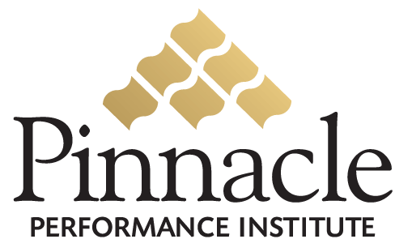

Sexual Harassment Certification System
Michael’s Stores, Inc., Dallas, Texas

Executive Summary

Michael’s Stores, Inc., the nation’s largest retailer of arts and crafts materials, has been helping crafters of all ages express their imaginations with skill and originality. With a broad assortment of products, knowledgeable and friendly associates, in-store events, classrooms, and instructional displays, they offer a shopping experience that inspires their customers to pursue their creative goals. At Michaels they provide the ideas and education to complete an array of artistic, leisure, and home décor projects for beginners and experts from start to finish.
Michaels is faced with a unique legislative challenge in the state of California, which is requiring all management status employees to receive a minimum of two hours training on sexual harassment by December 31, 2005. Michaels has the additional challenge of completing the legislative requirement by September 1, 2005 so as not to interrupt its 2005 Christmas season retail business.
Pinnacle will develop a custom online Michaels Performance Enhancement Solution to enable Michaels to train and certify their management on regulated sexual harassment requirements and other training needs determined by Michaels. Michaels will also have complete management reporting capabilities on all training classes and certifications for internal and auditing purposes. Additionally Michael’s store management will be able pose live questions regarding sexual harassment and receive expert responses via the live online conference rooms and discussion boards of their custom online Performance Enhancement Solution.
Michael’s management employees in California taking the sexual harassment training and certification will be able to do so from the privacy and comfort of their own home or any other location with Internet access due to the SECURED Universal access of Michaels custom Performance Enhancement Solution. Additionally, optional personal training will also be available to the employees and their families at no additional cost to offset the use of their personal computers and time.
The Michaels Performance Enhancement Solution has no setup or maintenance fees and will be developed at no cost to Michaels. The Michaels solution will be provided as a service to its employees for compliance certification on regulatory requirements to eliminate Michael’s legal liabilities due to sexual harassment, discrimination and other related issues.
The sexual harassment certification service will be administered at a cost of $25 per employee and can be completed by July 31, 2005. This solution is provided at one third of Michael’s projected cost and can be complete one month ahead of Michael’s projected schedule.
An Account Executive assigned by Pinnacle will partner with the Michaels Program Manager with custom solution implementation and ongoing solution support. The Pinnacle customer support department will also provide additional assistance for the program manager, trainers and employees.

